NAME: PRATIBA.S DATE:25.08.25 ROLL NO.:241901080

# EXERCISE 4

**DEVELOP A CUSTOMIZED PING COMMAND TO TEST THE SERVER CONNECTIVITY**

**AIM:**

To perform ping to a remote host,extract,RTT values from ping response and compute the minimum,maximum and average round-Trip time.

**ALGORITHM:**

1. Run the ping command using python’s subprocess module.
2. Capture the output of each ping replay
3. Extract RTT values using reg ex or string passing
4. Store all RTTs in a list
5. Calculator and display:

* Minimum RTT
* Maximum RTT
* Average RTT

**CODE:**

import socket

import time

host = "google.com" # you can change this

port = 80 # HTTP port

count = 4 # number of pings

for i in range(count):

try:

s = socket.socket()

start = time.time()

s.connect((host, port))

end = time.time()

s.close()

print(f"Reply from {host}: time={(end-start)*1000:.2f} ms")

except Exception:

print("Request timed out")

Customized Ping Program to Measure Min, Max, and Average RTT

import socket, time

host = "google.com"

port = 80

count = 4

times = []

for i in range(count):

try:

s = socket.socket()

start = time.time()

s.connect((host, port))

end = time.time()

s.close()

rtt = (end - start) * 1000

times.append(rtt)

print(f"Reply from {host}: time={rtt:.2f} ms")

except:

print("Request timed out")

if times:

print("\nMin RTT =", min(times), "ms")

print("Max RTT =", max(times), "ms")

print("Avg RTT =", sum(times)/len(times), "ms")

**OUTPUT:**

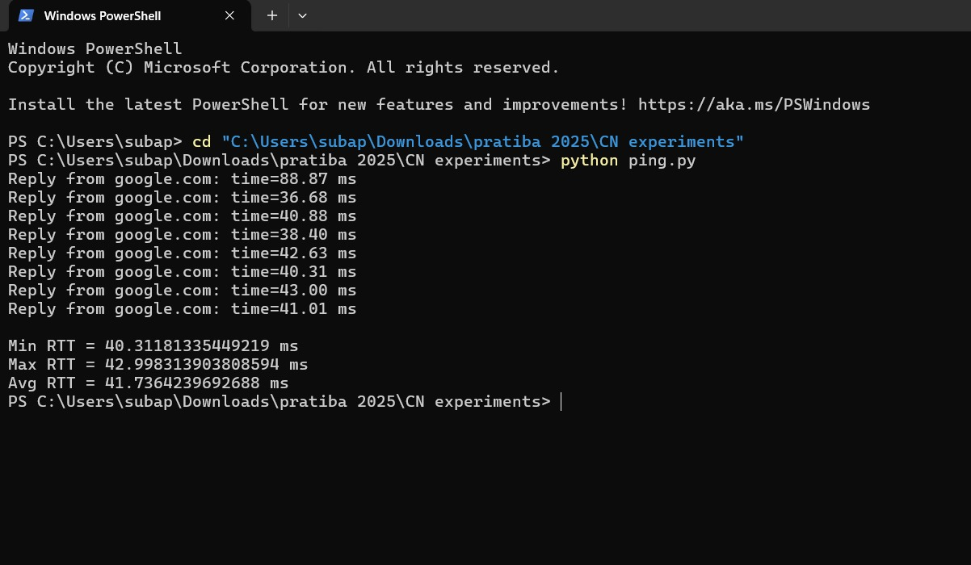

**RESULT:**

The program has successfully performed ping operations to google.com,extracted RTT values from the response and computed the minimum,maximum and average RTT.